

American Legion Auxiliary
Department of California

Convention Flower Order Form

Handmade Silk Corsages made by Sandy Phillips District 15
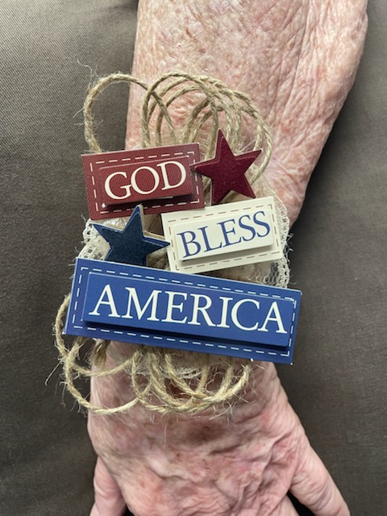 | 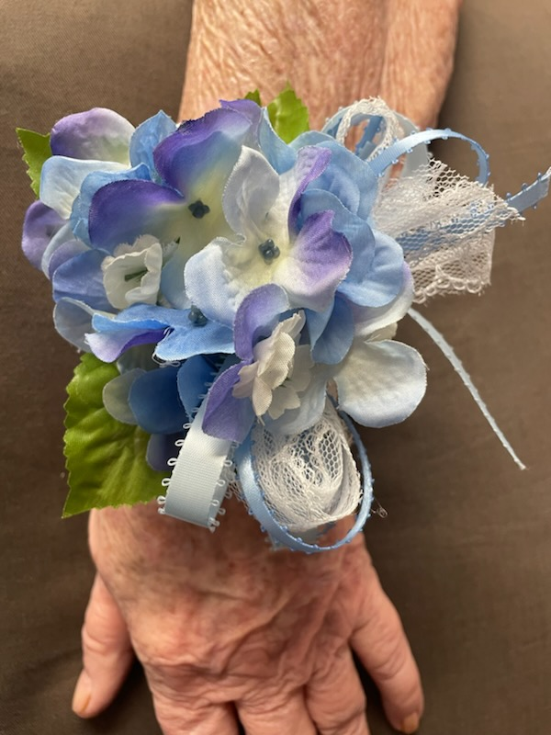 | 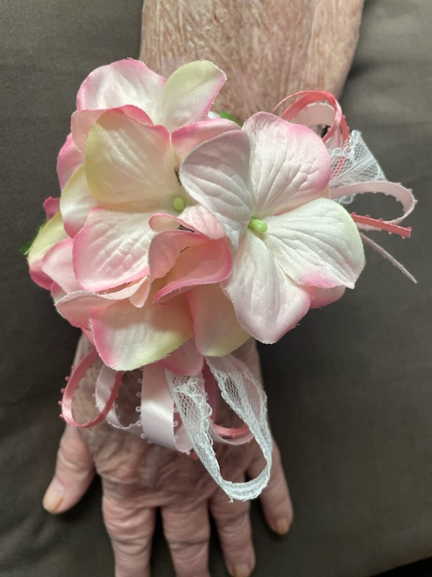

Option 1: God Bless America Option 2: Blue Option 3: Pink
There may be slight variations in the corsages based on supply issues.

Cost is $10.00 each
Please make order by June 11, 2025

Name ______________________________ Phone Number __________________________
District Number __________ Unit Number __________

Option 1 __________ Option 2 __________

Enclosed is Check # __________ in the amount of $ __________

Please make checks out to and mail to
Sandy Phillips
319 E J Street
Tehachapi, CA 93561-1420

For any questions, please call Sandy Phillips at 661-333-4975

They may be picked up at the Registration Tables

